**SPSS Command Cheat Sheet**

**Data Manipulation/Working in the SPSS Environment**

**Switching between data view and variable view**: Click the buttons at the bottom of the SPSS window. Or, use the menus: View 🡪 Data, or View 🡪 Variable.

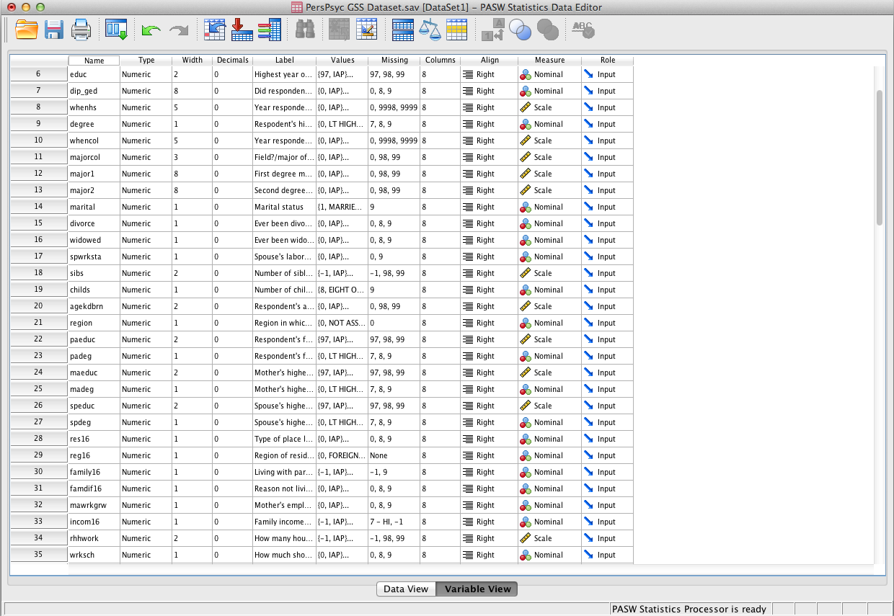

Unless otherwise specified, all commands can be executed from either Data view or Variable view. You can also execute menu commands from other windows within the SPSS environment, including the Output window.

**Creating a new data set or output file**: Go to File 🡪 New 🡪 Data, or File 🡪 New 🡪 Output. (SPSS automatically creates a new output file when you open the program.)

**Inserting a new variable**: There are FOUR ways to do this:

1. In Variable view, right-click the number of the variable *beneath* where you want to create the new one, then click Insert Variable.

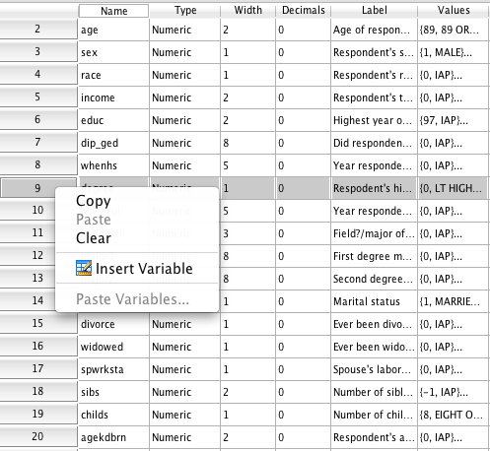

1. In Data view, right click the number of the variable *to the right* of where you want to create the new one, then click insert variable. (It looks very similar to the above screen shot.
2. In Variable view, select the variable beneath where you want to create the new one, then click the Insert Variable  button on the toolbar. You can also do this in Data view by selecting the variable to the right of where you want to create the new one, then clicking the Insert Variable button on the toolbar.
3. In Variable view, select the variable beneath where you want to insert the new one, then go to Edit -> Insert Variable. You can also do this in Data view.

**Sorting Variables**:

1. In Data View, right click the name of the variable by which you wish to sort, then select either “Sort Ascending” or “Sort Descending.”

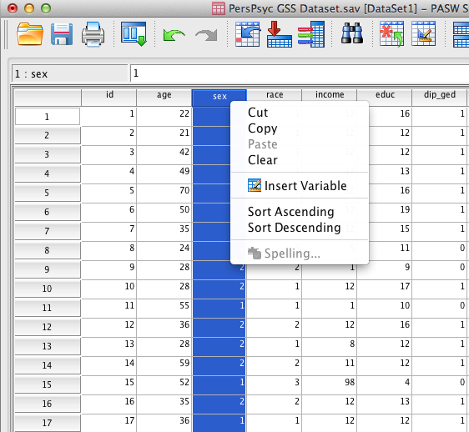

1. You can also do this from the menus, by going to Data 🡪 Sort Cases. This also gives you the option to sort by several variables at once (e.g., to sort first by race and then by age if you want.

**Selecting Cases**: You can select cases based on certain case criteria.

1. Go to Data 🡪 Select Cases, OR hit the Select Cases button  in the toolbar. The box you get is presented below.
2. Select the radio button “If condition is satisfied”. Then click the button “If…”

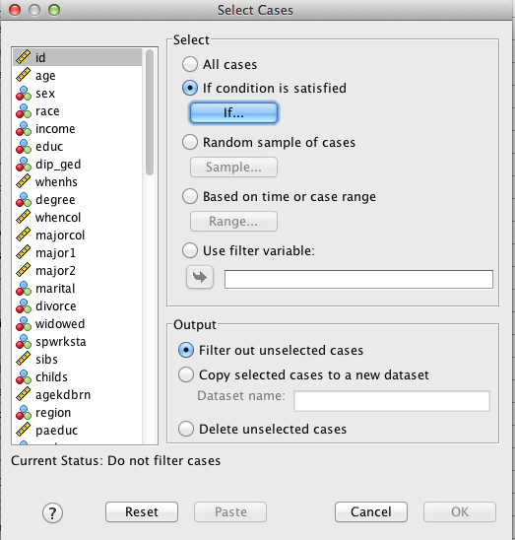

1. Create your selection rule here. For example, if you wanted to select only the cases for which the variable race was 1, you would move the variable race over into the box, enter an = sign, and then enter 1. Hit Continue.

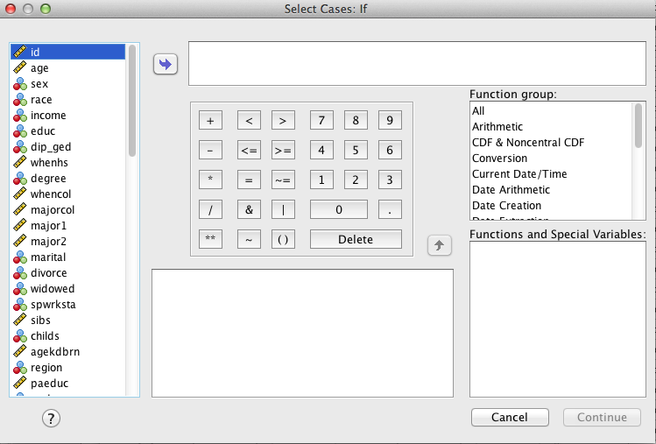

1. Select what you want SPSS to do from there. You can ask it to simply filter out the unselected cases, which leave them in the same data set but only performs further actions on the selected cases (recommended in 90% of situations). You can copy the selected cases to a new dataset (recommended only if you do not plan on running any analyses on the unselected cases at all). Or you can ask it to delete the unselected cases (NEVER recommended!). After you decide, hit OK.
2. **REMEMBER** that you have to turn off Select Cases! To turn it off, go to Data 🡪 Select Cases (or hit the toolbar button), and then just select the “All cases” radio button.

**Go to a specific case or variable**

1. Go to Edit -> Go to Variable or Edit 🡪 Go to Case in the menu, or you can click on the Go To Variable button  or the Go To Case button  in the toolbar. (Note that you can switch between them within the Go To box.)

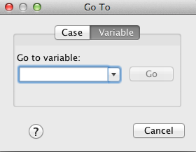

1. Start typing in the name of your variable. SPSS will give you a list in that drop-down box once you have typed in a few letters. Select one, or finish typing, and then hit Go. Or, if you are trying to go to a specific case, just type in the case number, then hit Go. (Note that SPSS only takes you to specific case numbers that are assigned by the file, NOT to ID numbers that you or whoever created the data set have generated.)

**Switch to viewing the value labels in the Data view, instead of the variable codes**: Let’s say for the race variable, you want to see “Black” and “White” instead of “2” and “1”. In Data View, click the Variable Labels button  on the toolbar.

**Creating New Variables from Already Existing Variables**

These are the operations you will use to create total scores for your personality scales, or to reverse code questions on those scales.

**Reverse coding questions**: Remember, you always want to create a new variable to do this – you do not want to reverse code in the same variable, just in case you make a mistake or you need the original variable later.

1. Insert the new variable where you want it, then give it a name.
2. Go to Transform -> Recode into Different Variables…

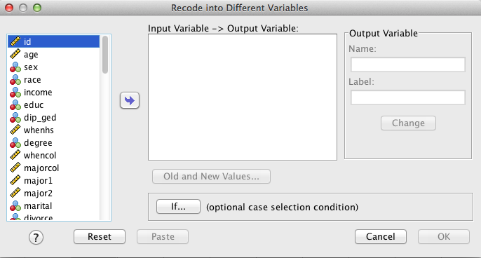

1. From the box on the left, move the original variable into the box in the middle by selecting it and hitting the arrow.
2. Under Output Variable, enter the name of the variable you just created. Make sure that you spell it exactly the same as you spelled it when you created it, otherwise SPSS will just create a new variable. It would also be a good idea to enter a variable label here. Then hit Change. SPSS will generate a warning to tell you that you are about to overwrite an existing variable (the blank one that you just created).
3. Press “Old and New Values…” underneath the box.

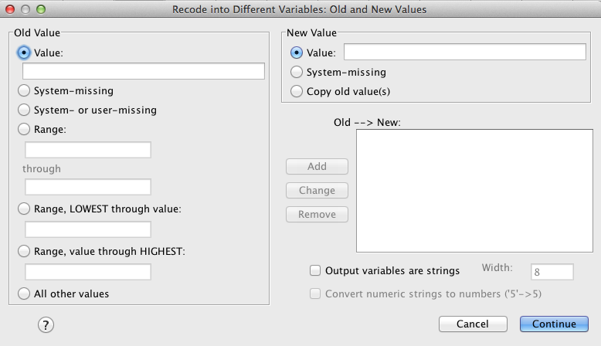

1. Under Old Value, enter the value in the original variable that you want to convert. You can also elect to convert System-missing variables into new values, or a range of values into new ones (e.g., let’s say you want to categorize everyone under 25 into an “under 25” category, you can select the “Range, LOWEST through value” radio button and then enter “24” into the box).
2. In the New Value box, you enter the new value you want. Then press Add.
3. If you made a mistake, select the Old 🡪 New in the box, then make your changes and hit the Change button. If you accidentally added one that you want to remove altogether, just select it and hit Remove.
4. Click Continue. Then, in the original box, Click OK.

**Computing total scores**

1. Insert the new variable where you want it.
2. Go to Transform 🡪 Compute Variable…

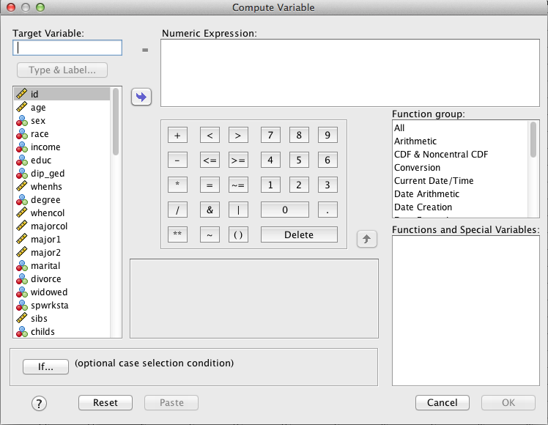

1. Type in the name of the variable that you just created.
2. Use the commands within this box to do what you want. For example, if you are creating a total score, then bring over the first item in the scale, hit the + button, then bring over the second item, hit +, and so on and so forth.
3. Hit OK.

**Analyzing Data!**

**Generating descriptive statistics, also known as “frequencies”** There are two ways to do this, and they give you slightly different information.

*More information/exactly what you want:*

1. Go to Analyze 🡪 Descriptive Statistics 🡪 Frequencies.

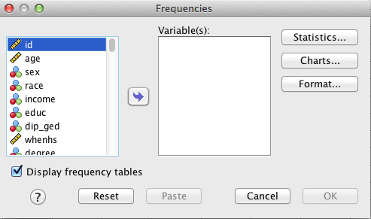

1. Move over the variables that you want into the Variables list.
2. If you are adding over continuous variables, hit the Statistics… button.

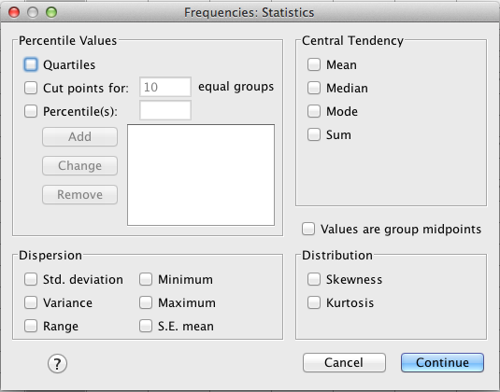

1. Select the statistics that you want. (None of these statistics makes sense for categorical variables, except maybe the mode, but you can easily figure that out from the frequency tables. So you don’t need to do this for categorical variables. For ordinal variables, you may want to know the median and the max and min, if you have a lot of ordinal categories BUT if you are doing frequencies for categorical and continuous variables at the same time, you will need to select these, and SPSS will generate these statistics for all of your variables. You need to ignore them for the categorical ones).
2. If you want any charts, like bar charts or pie charts, hit “Charts…” and select the one you want.
3. Back in the original box, IF you are performing frequencies on ONLY continuous variables, uncheck the box that says “Display frequency tables.” (IF you are performing it on a mix of categorical and continuous variables, leave it checked. You will unfortunately get a frequency table for all of your continuous variables as well.)
4. Hit OK.

As stated, this doesn’t make a distinction between categorical and continuous variables – it gives you frequency tables for all of them and all of the statistics you asked for for all of them.

*Less information/quicker way*

1. Select the variables you want to generate frequencies on (you can do this in Data view or Variable view).
2. Hit the Frequencies button. (It looks like an SPSS data set with a **μ** in front of it.)
3. This version of the command gives you frequency tables for the categorical variables and basic descriptive statistics for the continuous variables. However, it will only do it correctly if you have correctly specified the measurement level of your variable. You can fix this in Variable view.

**Generating crosstabulations and chi-square analyses:**

1. Go to Analyze 🡪 Descriptive Statistics 🡪 Crosstabs.

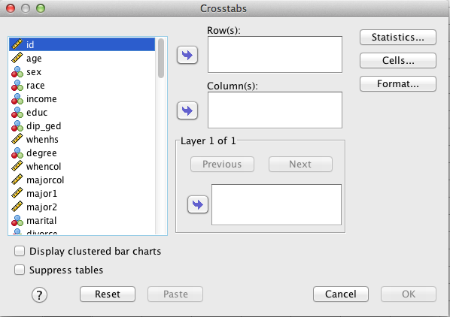

1. Bring over the variables that you want to create a crosstab table for into the Rows and Columns. When are you crosstabbing two variables (which you will do in the vast majority of cases), it doesn’t matter which one you select for the column and which one you put in the rows. But traditionally, the hypothesized IV is put in the row and the DV in the columns.
2. Hit the Statistics… button, and then check the box that says Chi-square. Press Continue.
3. Hit the Cells… button, then check the box that says Expected (under Counts.) Press Continue.
4. Hit OK.

**Bivariate Pearson Correlations**

1. Go to Analyze🡪 Correlate 🡪 Bivariate…

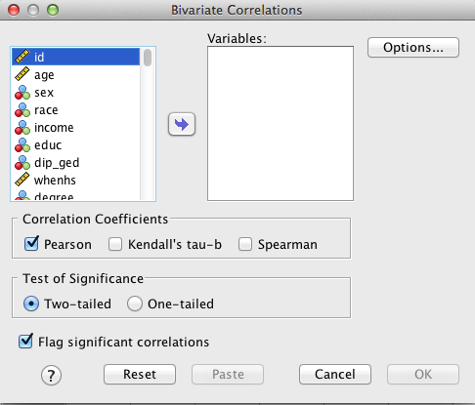

1. Select the variables that you want to correlate, and move them into the Variables list. It doesn’t matter what order you do them in.
2. Press OK.

**Independent Samples T-Test**

1. Go to Analyze 🡪 Compare Means 🡪 Independent Samples T Test…

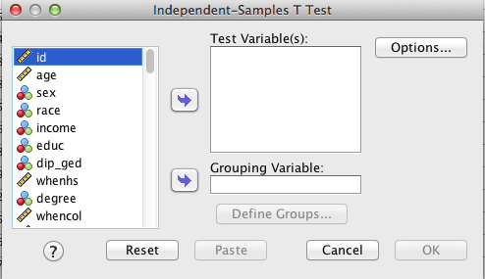

1. Move the dependent variable (continuous) into the Test Variables box.
2. Move the independent variable (categorical variable with two levels) into the Grouping Variable Box. Press Define Groups…, then enter the numbers that correspond to the codes of the two groups you want to compare.
3. Press OK.

**One-way Analysis of Variance (ANOVA)**

1. Go to Analyze 🡪 Compare Means 🡪 One-Way ANOVA…

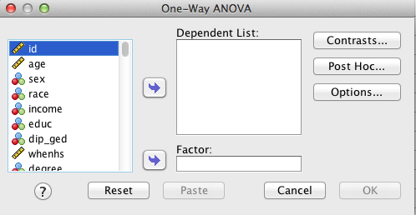

1. Move your dependent variable (continuous) into the Dependent List.
2. Move your independent variable (categorical variable with 3 or more levels) into the Factor box.
3. Press the Post Hoc… button.

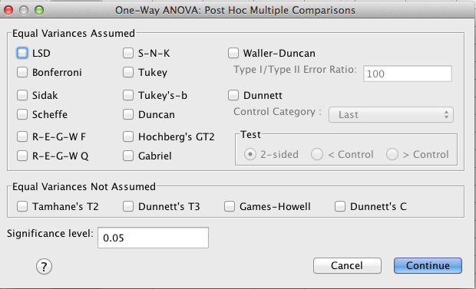

1. Select some post hoc tests. There are no hard and fast rules about which ones to select, but generally researchers select 2-3. If you only pick one, I suggest Tukey or Tukey’s-b. Other widely used ones are Sidak, Scheffe, and Bonferroni. The results are likely to be quite similar. Press Continue.
2. In the original box, press OK.

**Reliability Analysis**

1. Go to Analyze 🡪 Scale 🡪 Reliability Analysis…

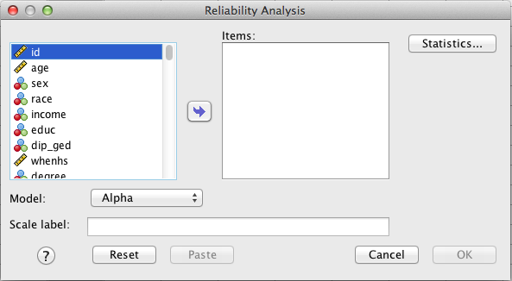

1. Move all of the items of the scale you want to analyze into the Items list. Make sure that you move over any recoded items instead of the originals.
2. If you want inter-item correlations, press Statistics…, then check the Correlations box under Inter-item. (Here you can ask SPSS for any statistics you want.)
3. Press Continue. In the original box, Press OK.